**ScienceLogic Initial Guide**

1. **Create Virtual Machines with VirtualBox**

For use of license is recommended to use VirtualBox by deploy virtual machines, because is a GNU General Public License, version 2.

1. **Install SL1**

Recommendations, for the installation of SL1 is recommended create a virtual machine with more than 80Gb in HardDisck and 10Gb of Ram, after the installation the user can reduce the Ram to 3 Gb.

For the installation of SL1 we used the “em7_x86_64_8.10.0-1023.iso”, this is a Linux Oracle OS, and this description should be put in the creation of the virtual Machine. The installation guide is at the URL: “<https://docs.sciencelogic.com/8-10-2/#Web_Install_Configure/Installation/installation_title_page.htm%3FTocPath%3DSection%2520II.%2520Installation%2520and%2520Configuration%7CInstallation%2520and%2520Initial%2520Configuration%7C_____0>”

|  |  |  |  |  |  |
| --- | --- | --- | --- | --- | --- |
| **QA** | **AIO** | **Dist DB** | **Dist CU** | **AIO MUD** | **WinServ2012** |
| Raul Diez Canseco | 172.26.93.101 | 172.26.93.102 | 172.26.93.103 | 172.26.93.104 | 172.26.93.108 |
| Christian Galarza | 10.30.140.162 | 10.30.140.161 | 10.30.140.163 | 10.30.140.168 | 10.30.140.169 |

Type: Linux

Version: Oracle(64-bits)

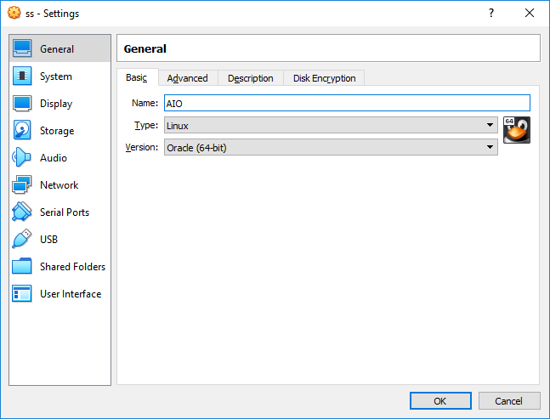

Network: Bridged Adapter

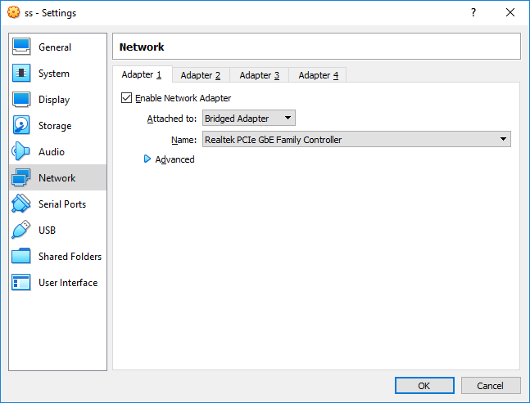

When the installation is started the main window is displayed, here the Enter key is pressed for star the instalation.

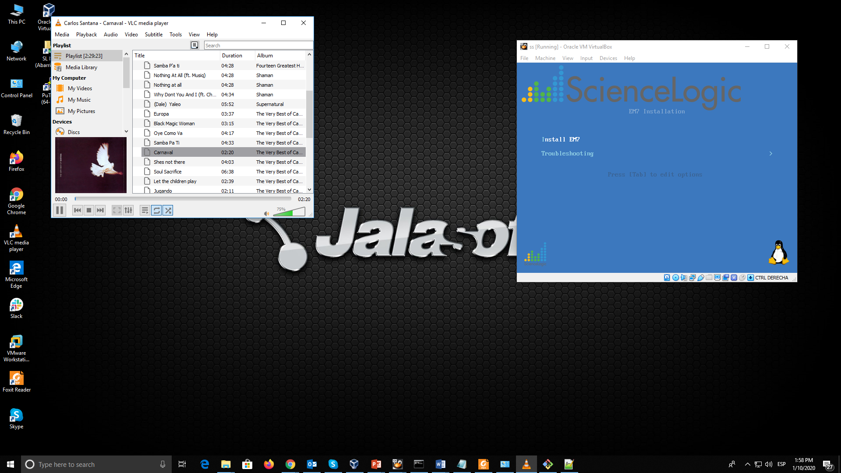

Almost all steps are similar to the All in One installation, when a difference step is needed it will be shown.

1. **All in One**
2. The model type is displayed an the “All in One” option is selected

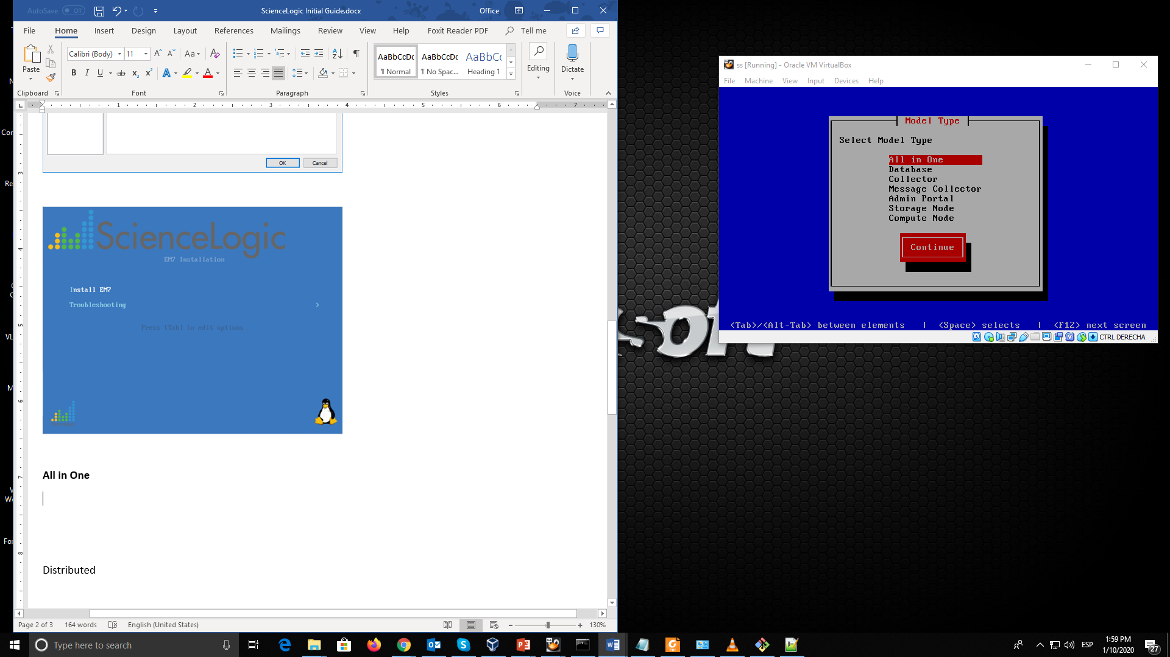

1. For a normal All in One instalation, the Military Unique Deployment is not marked

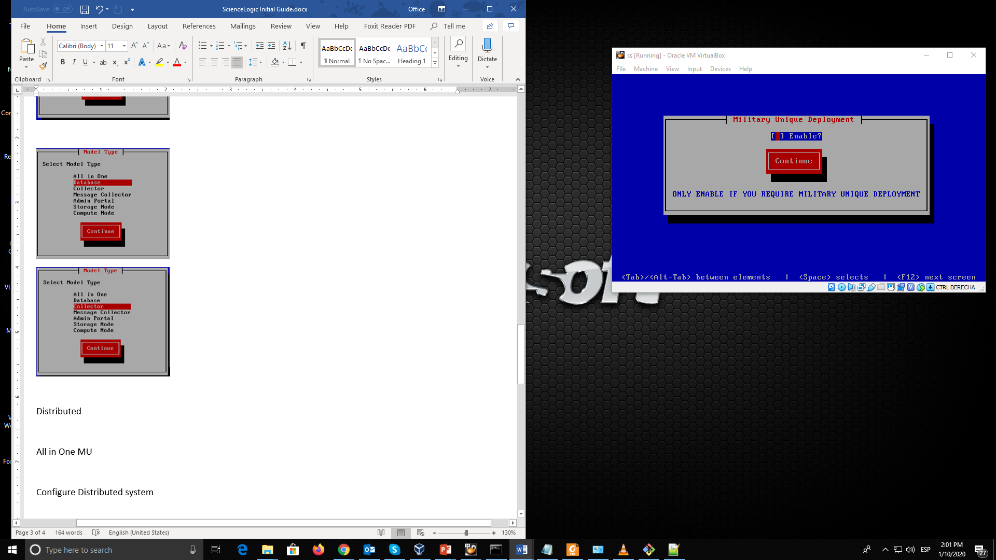

1. The Network Configuration is deployed in this step

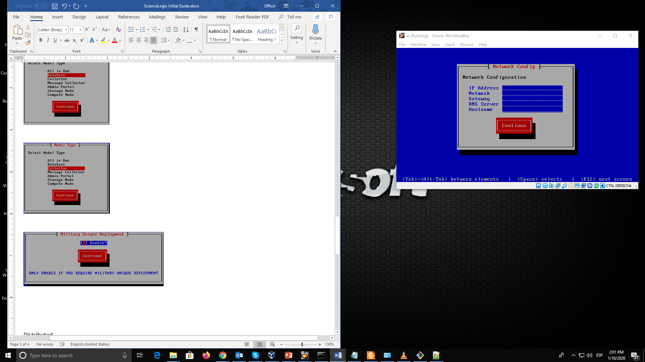

1. A password for em7admin is typed here, for test uses the password should be em7admin, it beed a confirmation

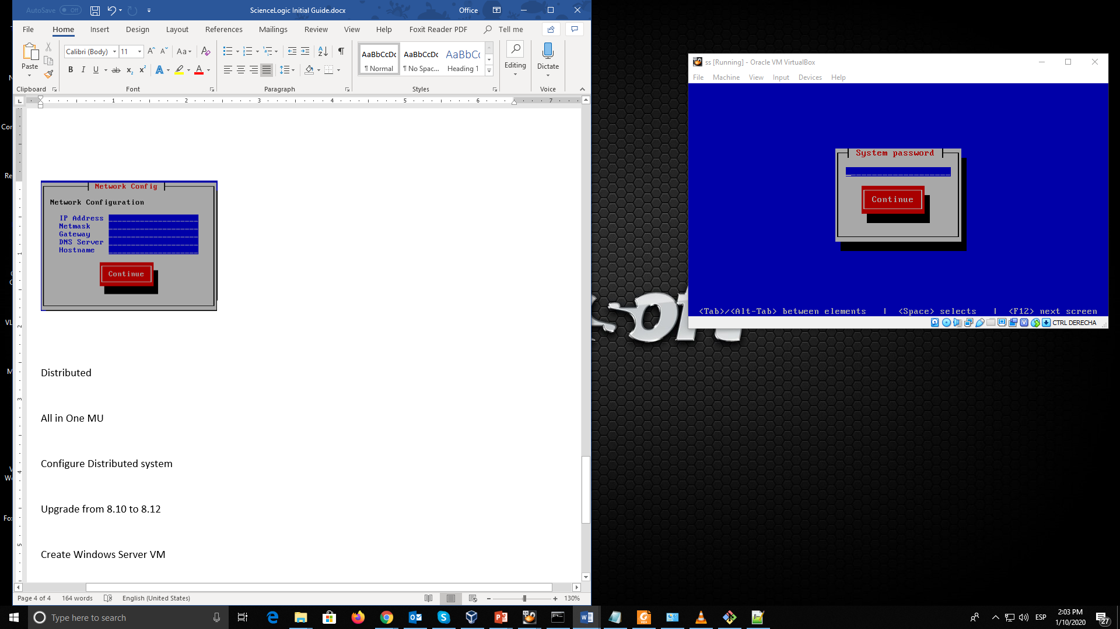

1. **Distributed**

The distributed installation need a Database and at least one Collector

For the Database

1. In the Model Type window the Database is selected

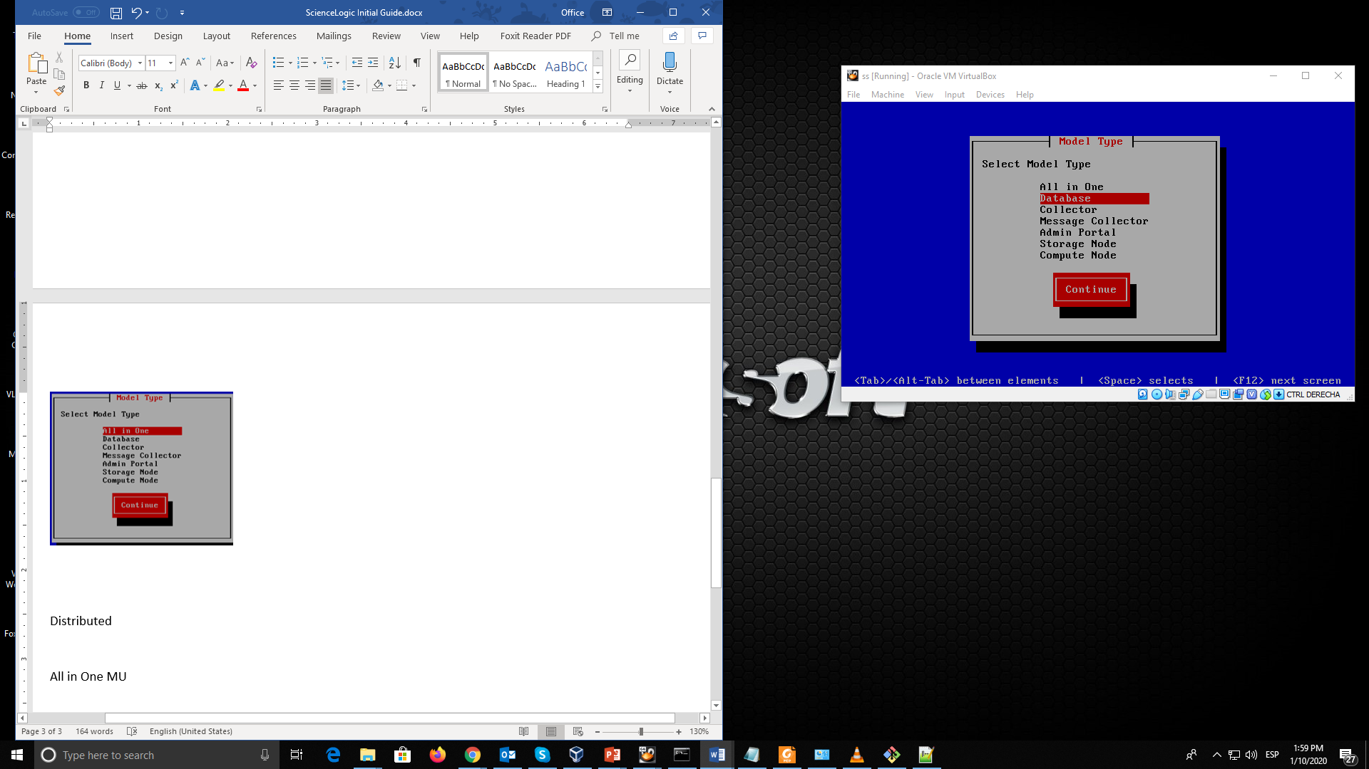

1. After selecting the Military Unique Deployment mode is necessary select the location of the Database

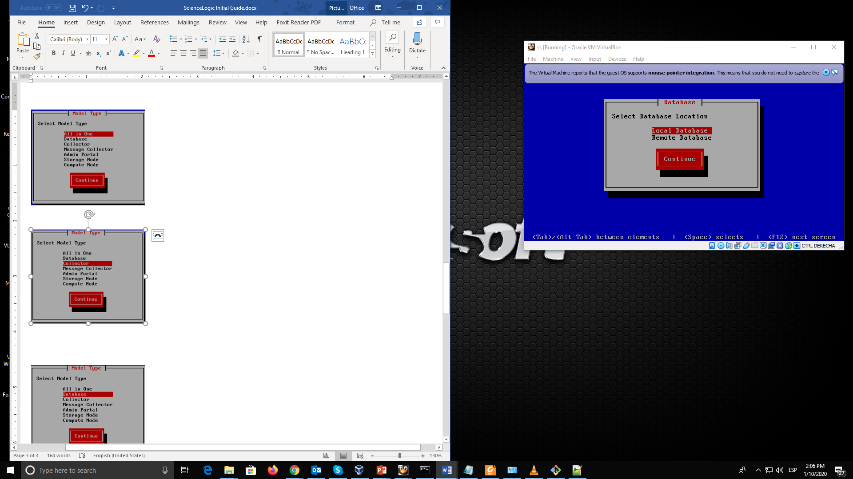

For the Collector

1. In the Model Type window the Collector is selected, if is needed the Message Collector works like this by selecting “Message Collector” option

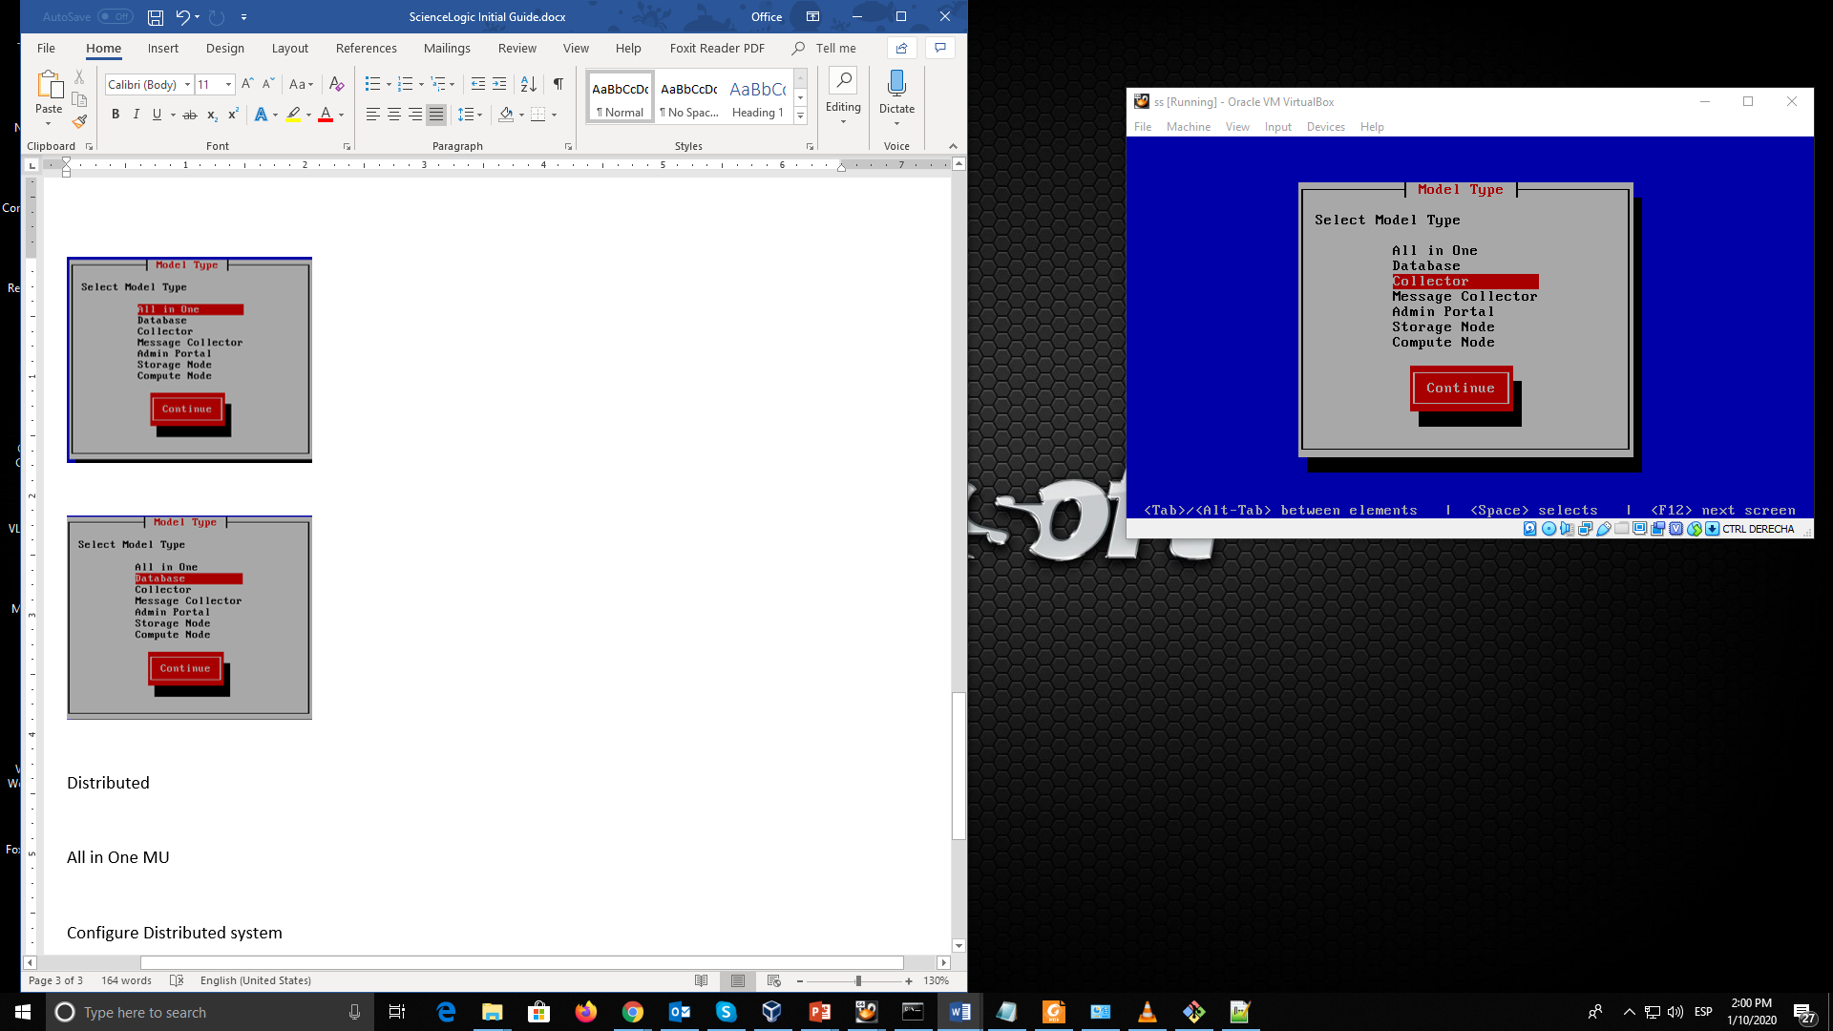

1. **All in One MUD**

The big difference with the Military Unique Deployment is that the rules of password, for this option is necessary to deploy a longer and more stricted password (near to 18 chars).

1. **Configure Distributed system**

After the installation of a distributed environment is necessary do some steps for associate the Data Collectors and Message Collectors to the Database.

In the browser is needed to write the IP address of the Collector with the configuration port

https://*ip-address-of-appliance*:7700

it will show the login page of the Configuration Utility, here is typed the em7admin user and the password did in the fourth step of the installation process. (em7admin)

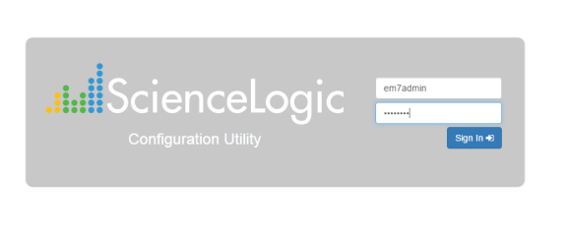

In the main page select the “Device Settings” option

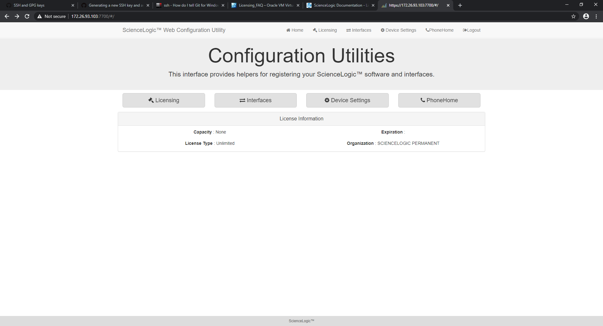

In Settings pague must be typed the IP address of the database, is the same for the Data Collector and the Message Collector.

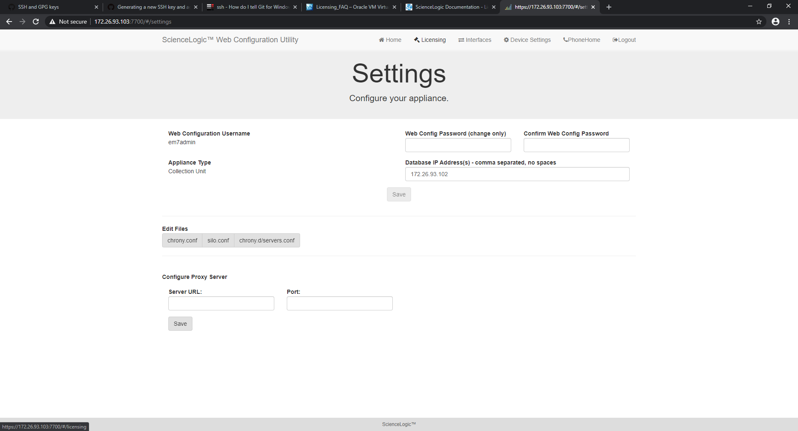

Then save the changes and logout of the Configuration Utility.

Register the Data Collector or Message Collector with the Database Server

In the Database site (<https://ip-address-DataBase>) logged with the user em7admin.

In the Appliance Manager page (System > Settings > Appliances) register the Data Collector (and the Message Collector), writing the Host Name, IP Address and choosing “Data Collector Unit” in Model Type (or Message Collector Unit), click on Save button and the collector is displayed in the list

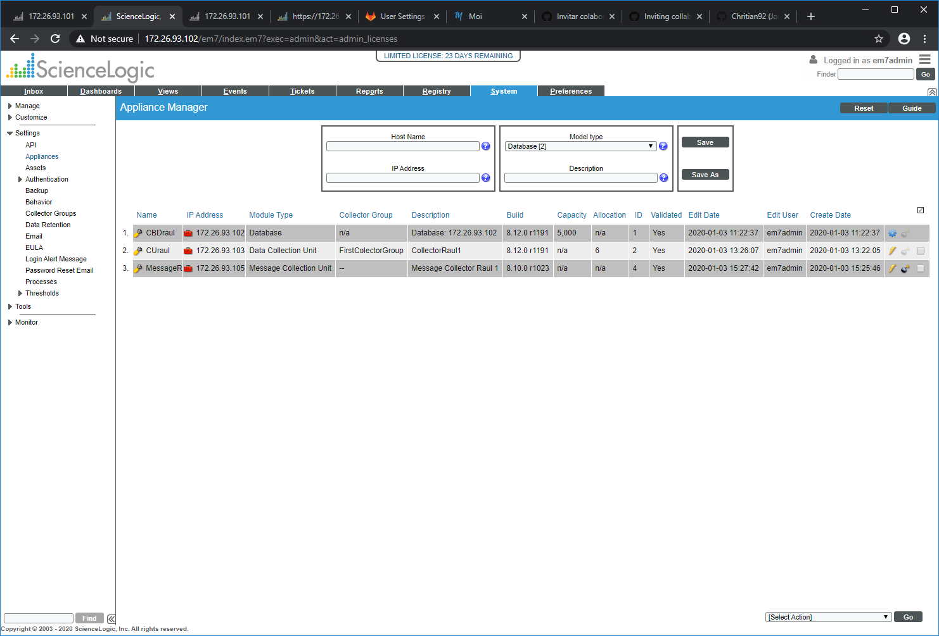

To know if the collector is correctly recognized, it must have a value in the column Build, if it not yet recognized click on the lightning icon .

Create a Collector group

1. Go to the Collector Group Management page (System > Settings > Collector Groups).
2. In the Collector Group Management page, click the Reset button to clear the values from the fields in the top pane.

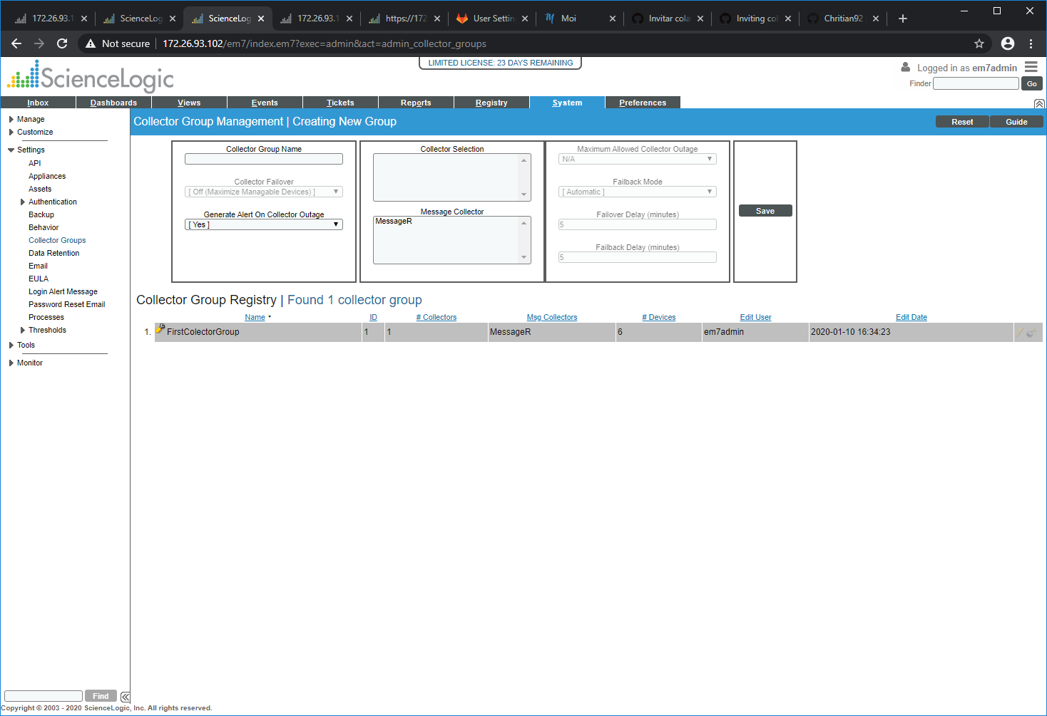

1. Go to the top pane and enter values in the following fields:

* Collector Group Name. Name of the Collector Group.
* Collector Selection. Displays a list of available Data Collectors.
  + To assign an available Data Collector server to the Collector Group, simply highlight it. You can assign one or more Data Collectors to a Collector Group.
  + To assign multiple Data Collectors to the Collector Group, hold down the <Ctrl> key and click multiple Data Collectors.
* Message Collector. Displays a list of available Message Collectors.
  + To assign an available Message Collector to the Collector Group, simply highlight it. You can assign one or more Message Collectors to a Collector Group.
  + To assign multiple Message Collectors to the Collector Group, hold down the <Ctrl> key and click multiple Message Collectors.
  + **Note** that a single Message Collector can be used by multiple Collector Groups.

1. **Create Windows Server Virtual Machine**

Create a Windows Server on virtualBox, is recommendable to be for Windows Server 2012 r2 because need less configurations.

Create a user in the Administrator group

1. **Enable Windows Server for SL1**

After the have a Windows Server with a valid user, is necessary to enable the windows for be used in SL1, the first step is:

Disable the Firewall

Console Command: netsh advfirewall set currentprofile state off

In the “PowerShell” execute those commands:

* Set-ExecutionPolicy RemoteSigned
* Set-WSManQuickConfig
* Enable-PSRemoting –force

In a console opened with Administrator Privileges execute those commands:

* winrm get winrm/config
* winrm set winrm/config/client @{TrustedHosts="*"}
* winrm set winrm/config/client/auth @{Basic="true"}
* winrm set winrm/config/client @{AllowUnencrypted="true"}
* winrm set winrm/config/service/auth @{Basic="true"}
* winrm set winrm/config/service @{AllowUnencrypted="true"}
* winrm set winrm/config/service @{MaxConcurrentOperationsPerUser="150"}
* winrm set winrm/config/service @{MaxConnections="50"}
* winrm set winrm/config/winrs @{MaxShellsPerUser="100"}
* winrm set winrm/config/winrs @{MaxProcessesPerShell="100"}
* winrm set winrm/config/winrs @{MaxConcurrentUsers="100"}

1. **Create the Windows Server device in SL1**

Before to create the device of Windows Server is a good practice to verify if is possible to do a ping to the server.

In the SL1 (AiO or Distributed CDB) is necessary create the credentials for discovery the Windows Server device, for it we go to “System/Manage /Credentials”, here click on Actions button (on the upper right corner), select “Create PowerShell Credential” option; the Credential Editor window is displayed

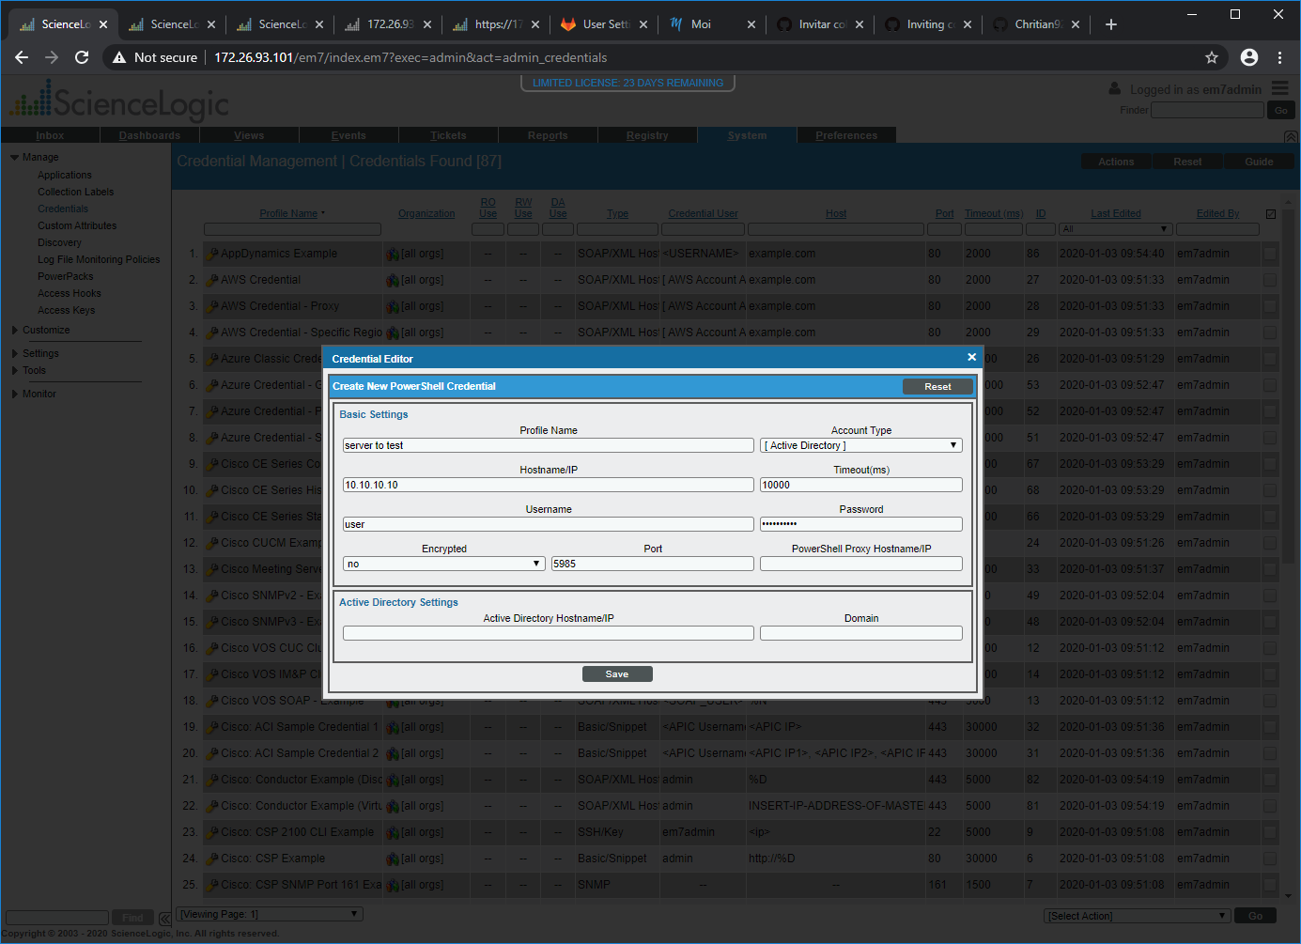

Write the data of the Windows Server

* Profile Name: the name that we give to the credential
* Hostname/IP: IP of the windows server
* Username: the user created in “Create Windows Server VM” section
* Password: the password of the user of the previous point
* Encrypted: this value must be change to NO for this practice
* The rest of the fields leave with their values.

With the credential created go to “System/Manage/Discovery”, here click on Create button (on the upper right corner); the Discovery Session Editor window is displayed

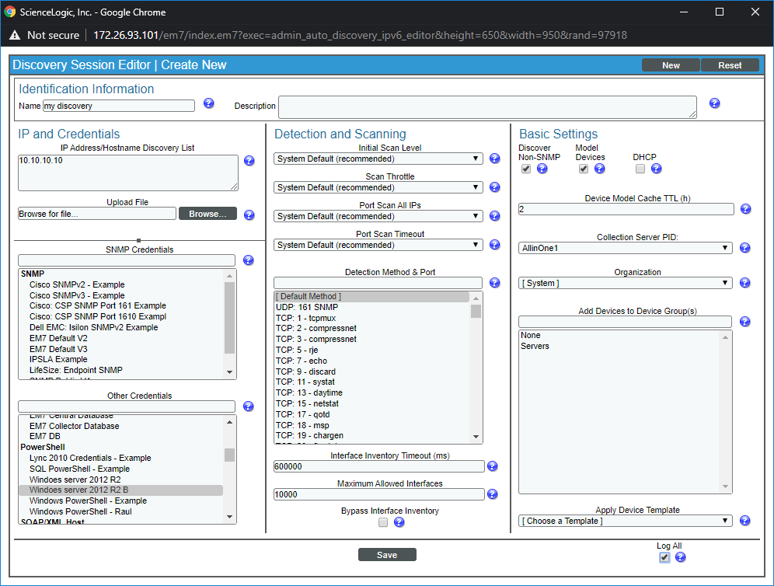

* Write a name for the Discovery Session
* Write the IPs of the devices that will be discovery
* Select the credential created previously
* Check the Discover Non-SNMP checkbox
* Check the Log All checkbox
* And click on Save button

After creating the discovery session, start an auto-discovery by clicking on  the icon, notice that device will be discovered like “Ping ICMP”. While the device is discovery, the window of the status of the process is displayed.

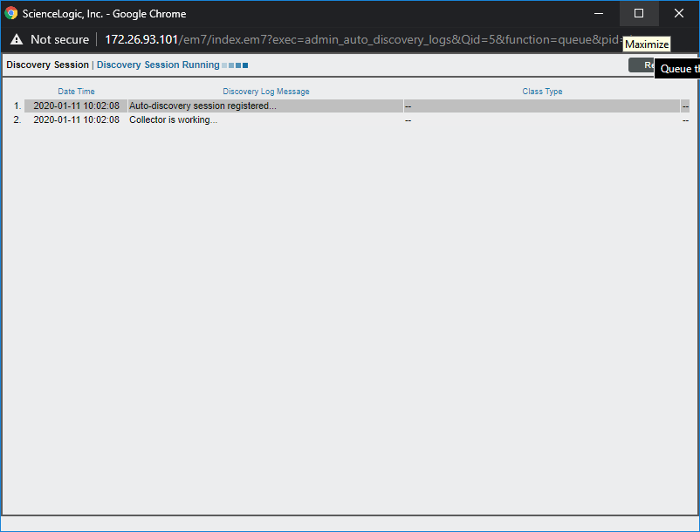

On “Registry/Devices/Devices Manager” is listed the device after discovery process

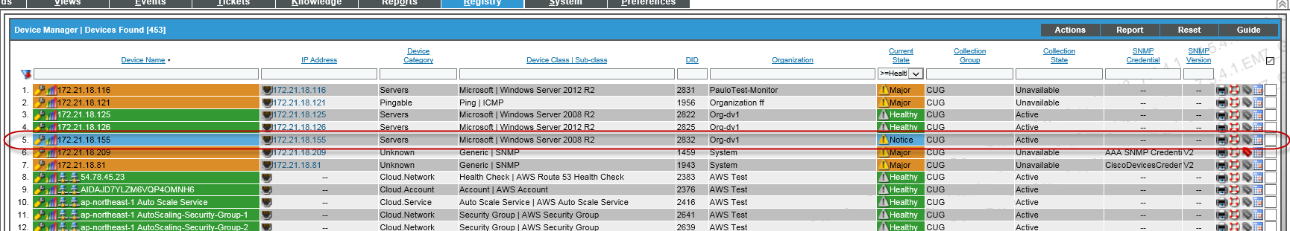

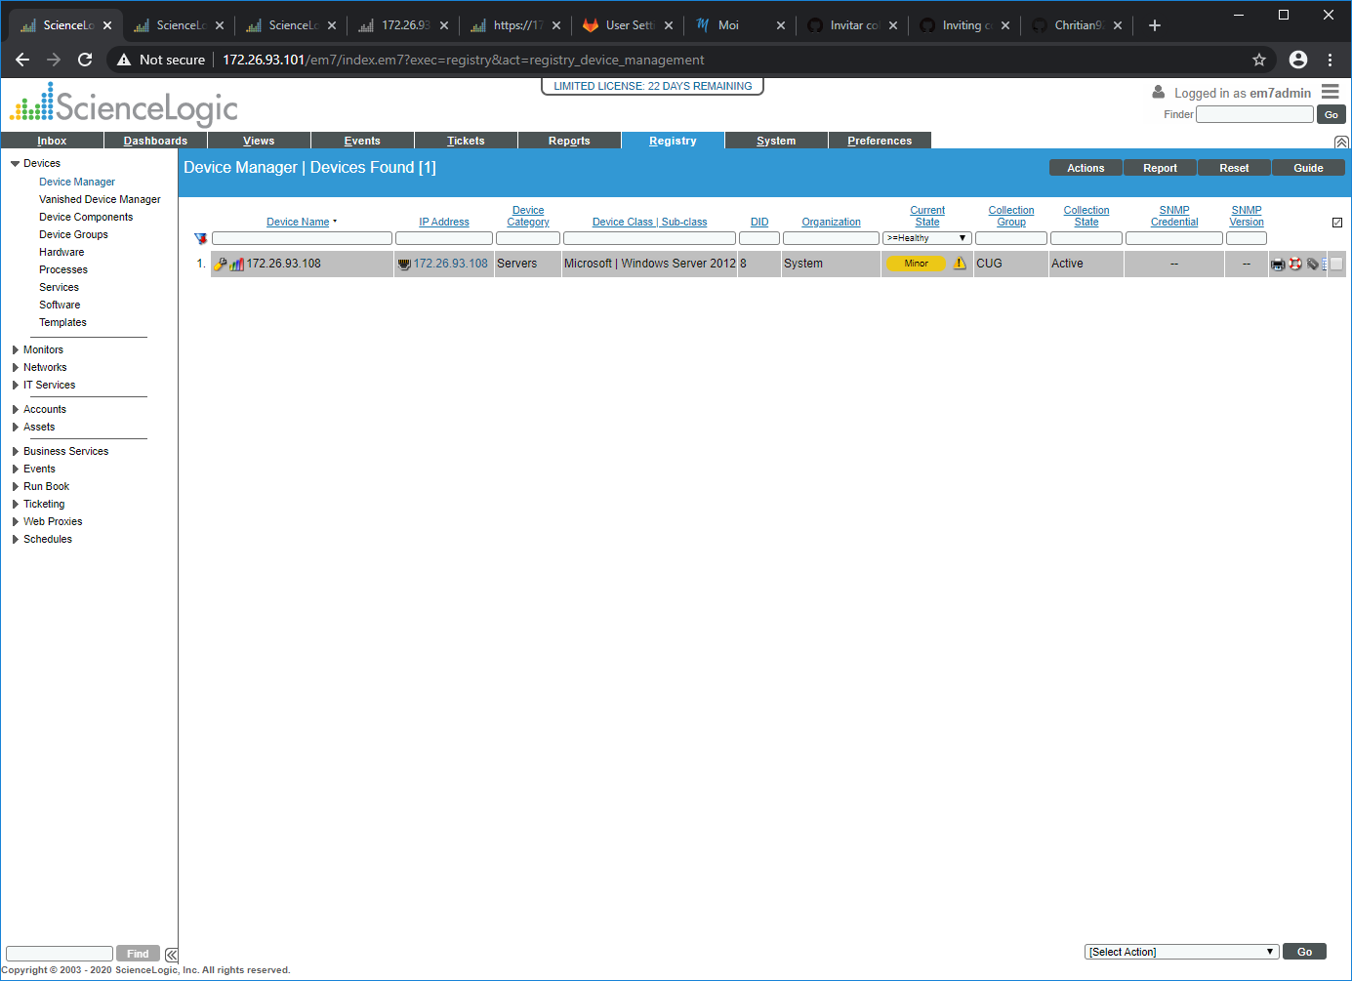

By clicking on the tool icon, the window with the properties of the device is displayed

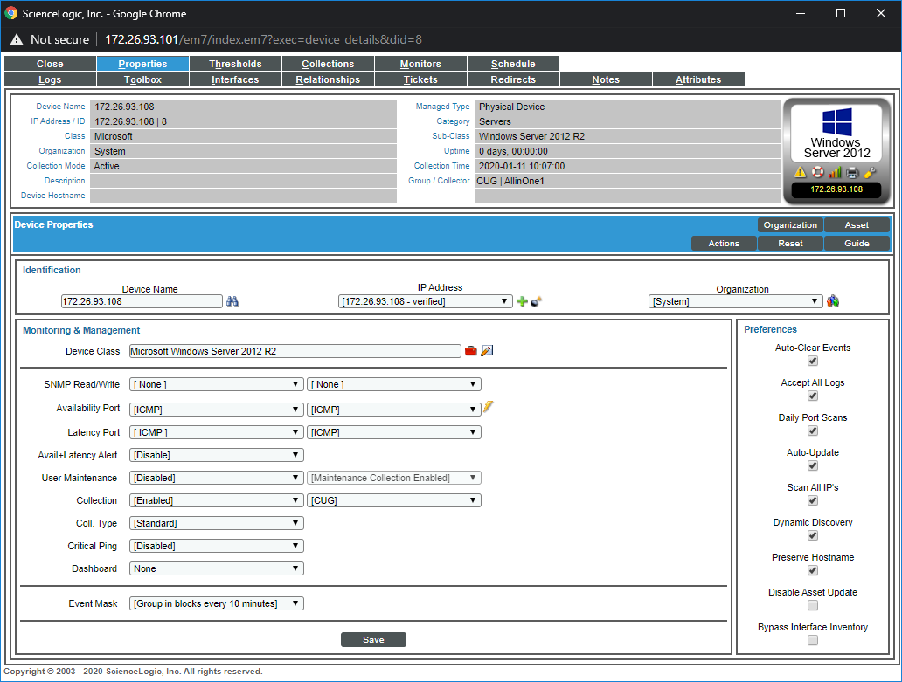

By clicking on the graphic bar icon, the window with the results of the device is displayed

